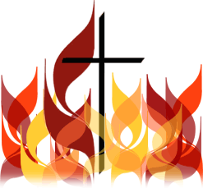

Confirmation Retreat
A day of reflection for those preparing to
receive the Sacrament of Confirmation
9:00am - 2:30pm
$25pp
Sacrament of Reconciliation and Holy Hour

Confirmation Retreat Team
Joe Haas, Seminarian, Archdiocese of New York
Bro. Gregg Durham, O.Carm
Carol Bezak, MA, Shrine Director

For further information or to reserve a date, please call
Carol Bezak, MA, Shrine Director, at 845-343-1879 or email to cbezak@carmelites.com

National Shrine of Our Lady of Mt. Carmel
A Ministry of the Carmelite Friars of the Saint Elias Province
70 Carmelite Drive, P.O. Box 2163
Middletown, NY 10940 - www.ourladyofmtcarmelshrine.com

